**Programs on Conditional and Iterative Structures**

1. Write a program to demonstrate the use of **FOR** Loop to calculate the factorial of a predefined number.

**Logic:**

* Start
* First package proj is created and main () method is created.
* Integer i and fact is created and for loop is used.
* for(i=1;i<=number;i++)
* fact = fact * i
* Than System.out.println statement is used to print the output.
* Stop

**Code:**

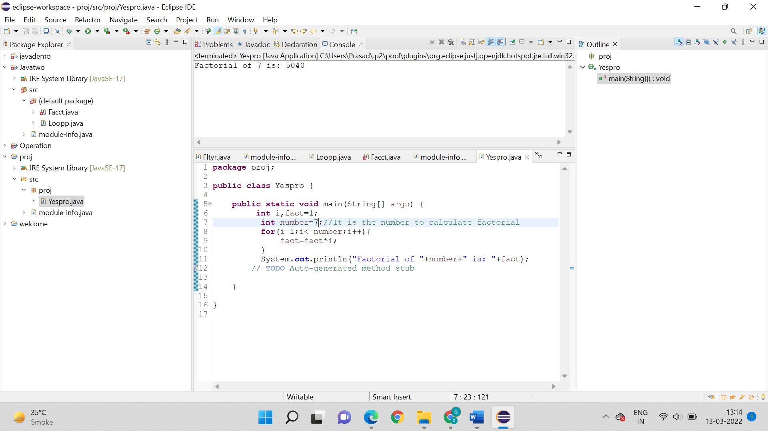

**Output:**

Factorial of 7 is: 5040



**2. Write a program to:**

**i. Calculate the Fibonacci series of a predefined number. Ex: If the number is 10 then ten elements should be there in the series.**

**Logic:**

* Start
* First package javademo is created along with main().
* Than int n, f and s are assigned values respectively.
* f + s
* f = s
* Output is printed by the statement system.out.println
* Stop

**Code:**

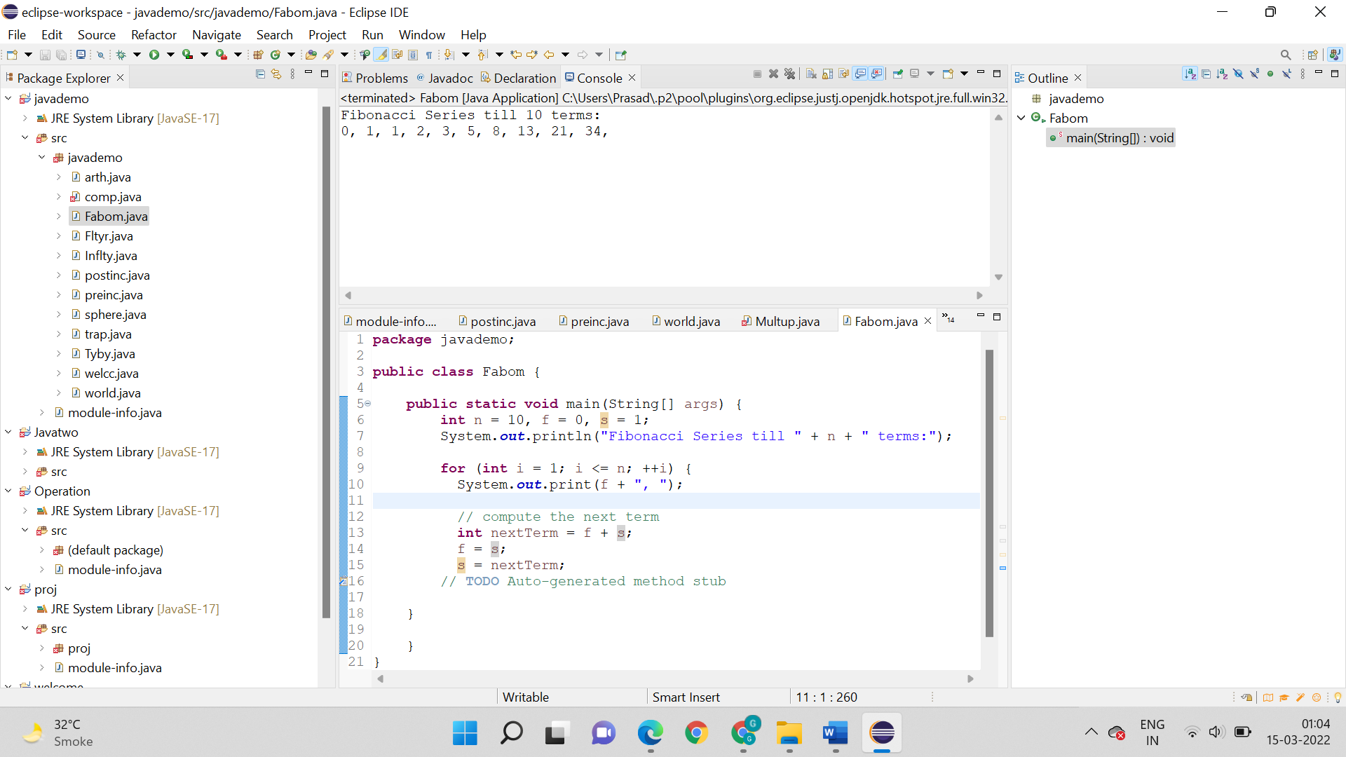

**Output:**

Fibonacci Series till 10 terms:

0, 1, 1, 2, 3, 5, 8, 13, 21, 34,



**ii. Calculate the Fibonacci series of all the numbers till 100.**

**Logic:**

* Start
* First package javademo is created along with main().
* Than int n, f and s are assigned values respectively.
* f + s
* f = s
* The value of n = 100
* Output is printed by the statement system.out.println
* Stop

**Code:**

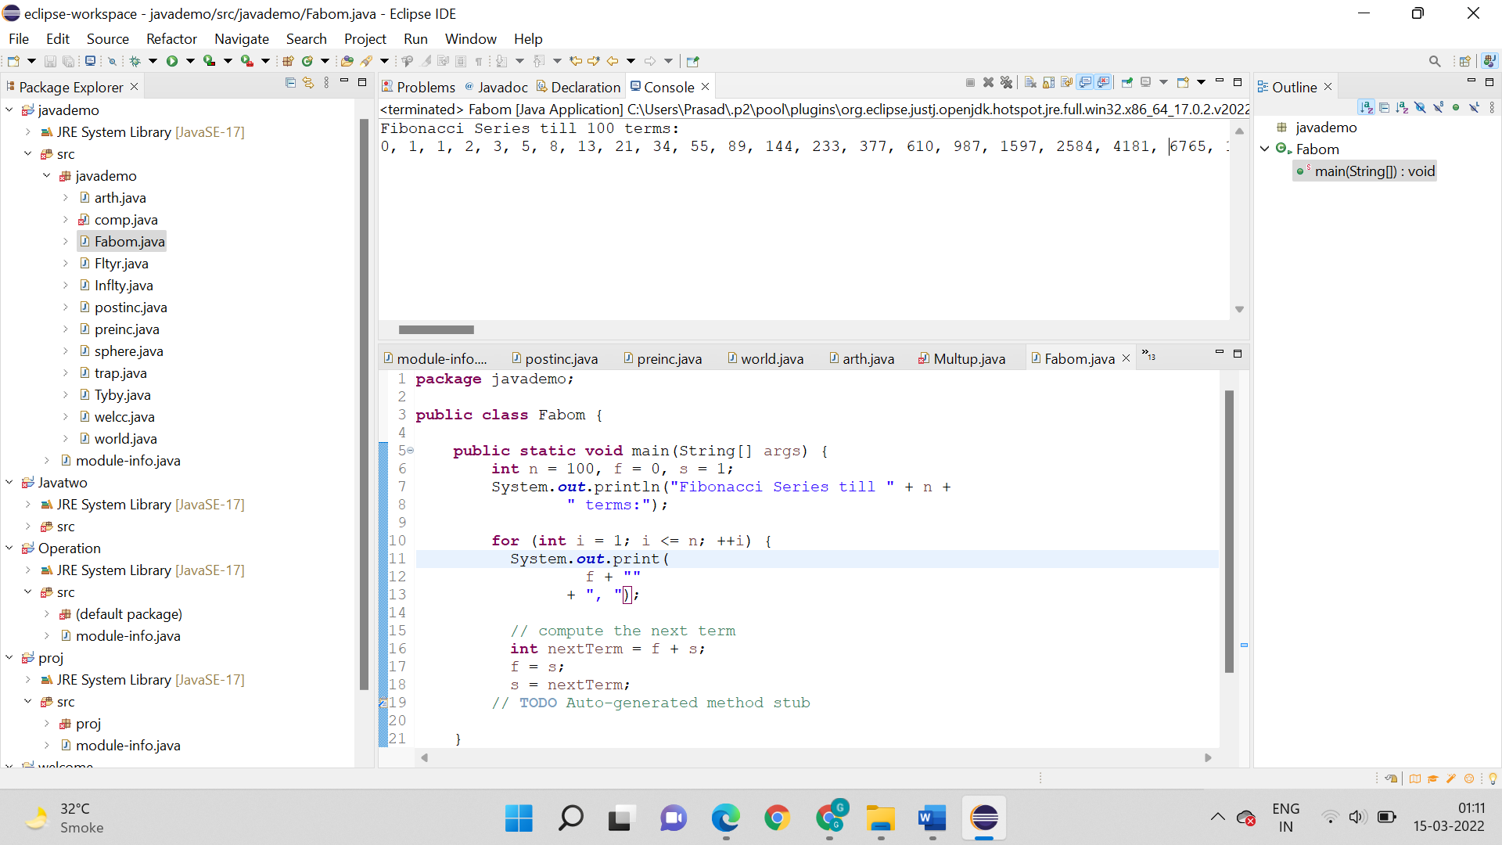

**Output:**



**3.** **Write a program to calculate a multiplication table for any predefined number.**

**Logic:**

* Start
* First package proj is created along with main().
* Than int num is assigned value = 6.
* For loop is used (int i =1; i<=10; ++i)
* Output is printed by the statement system.out.println
* Stop

**Code:**

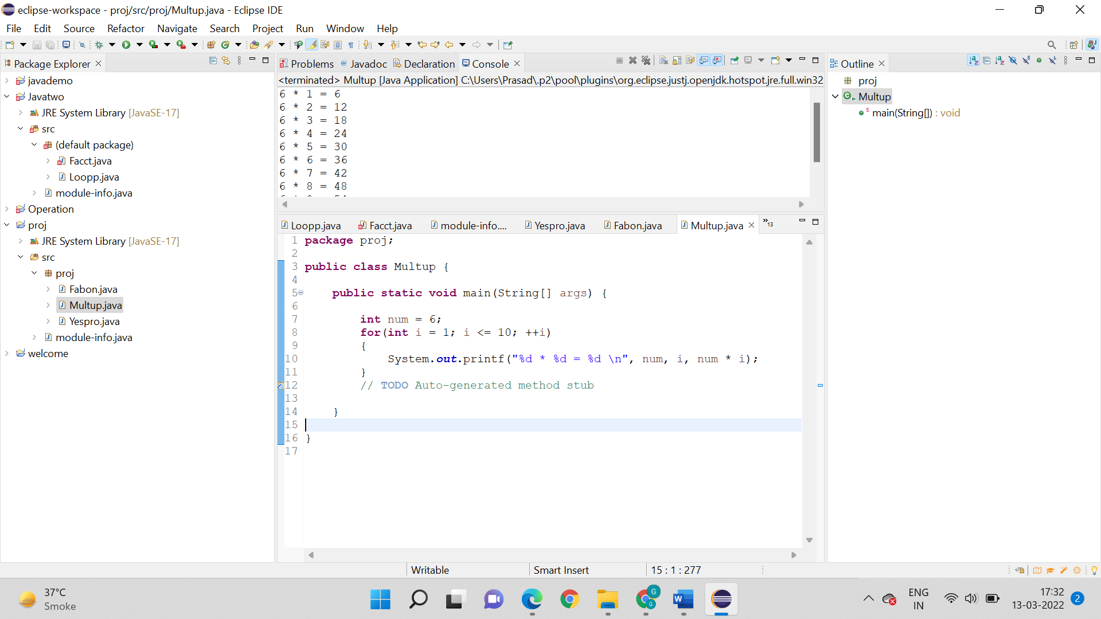

**Output:**

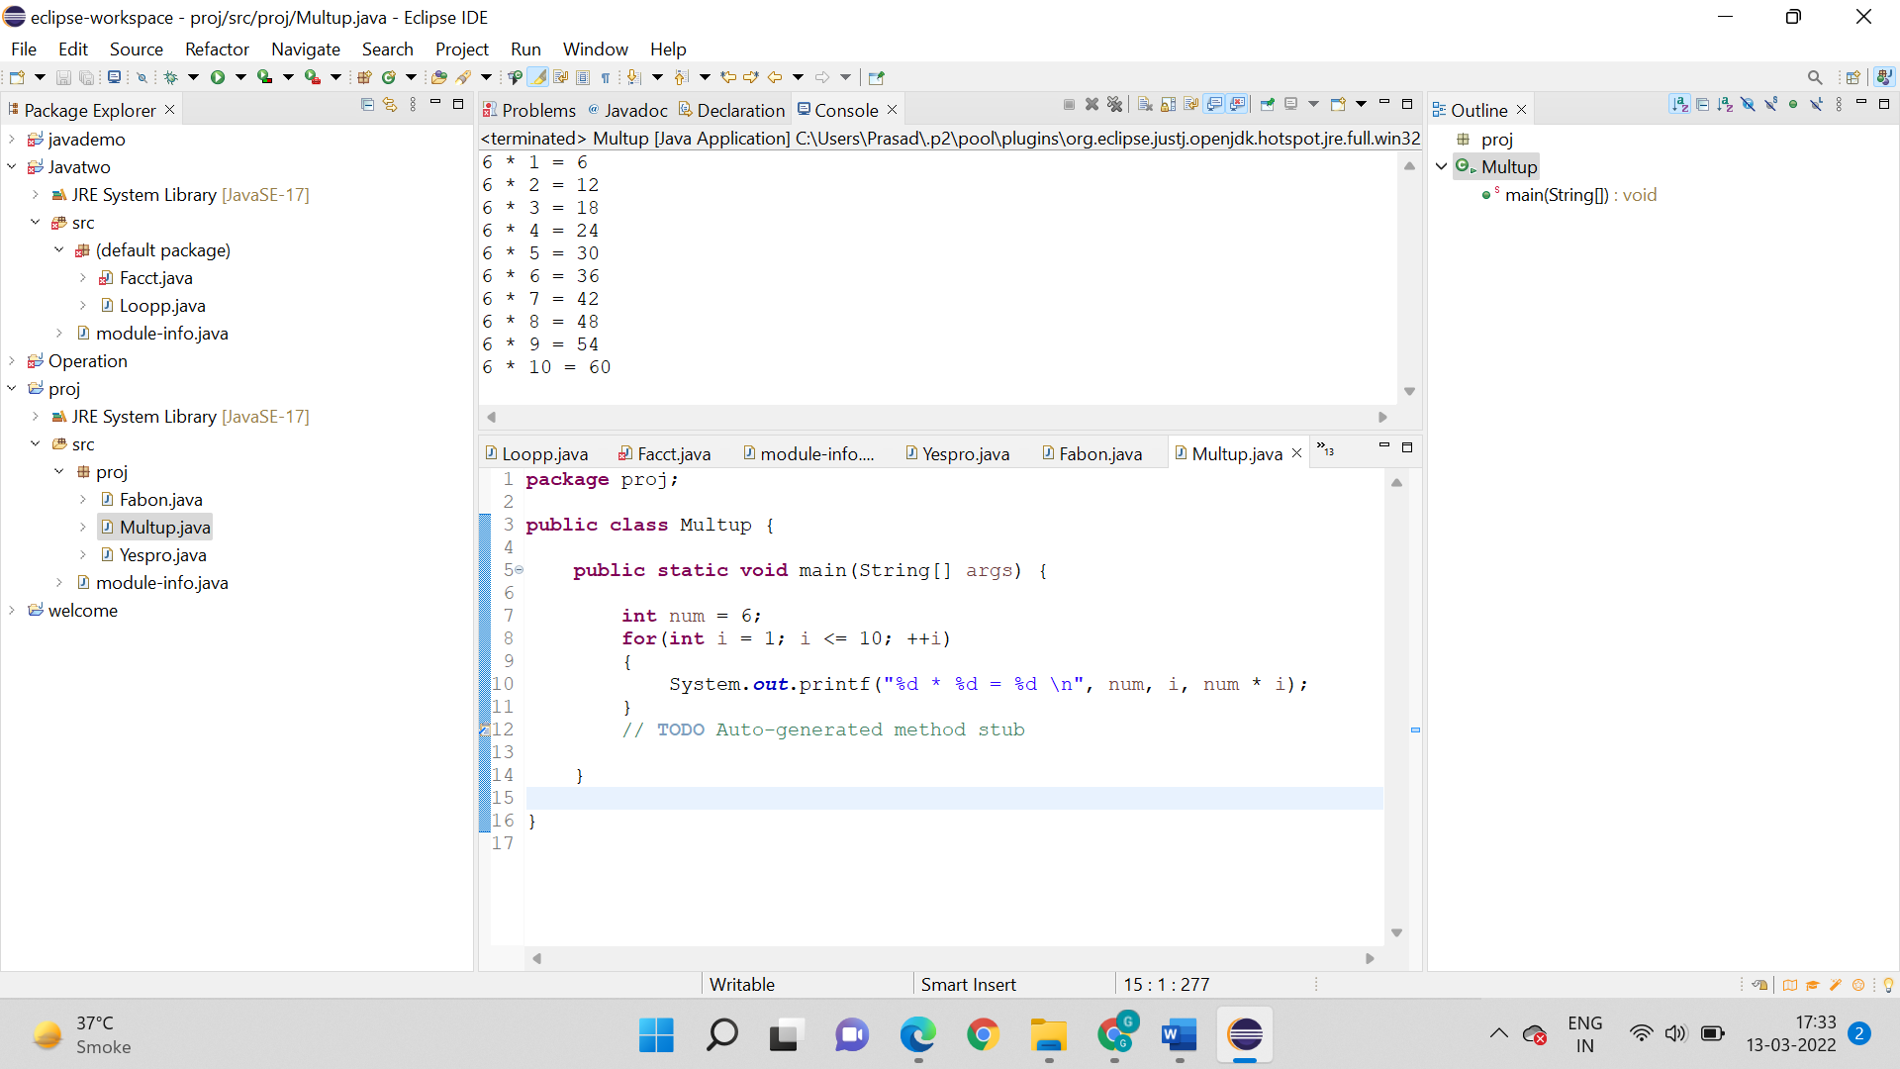

**4.** **Write a program to calculate the sum of the five-digit number.**

**Logic:**

* Read or initialize an integer N.
* Declare a variable (sum) to store the sum of numbers and initialize it to 0.
* Find the remainder by using the modulo (%) operator. ...
* Add the last digit to the variable sum.
* Divide the number (N) by 10.
* Sum=sum+n
* M=m/10;
* Output is printed by the statement system.out.println
* Stop

**Code:**

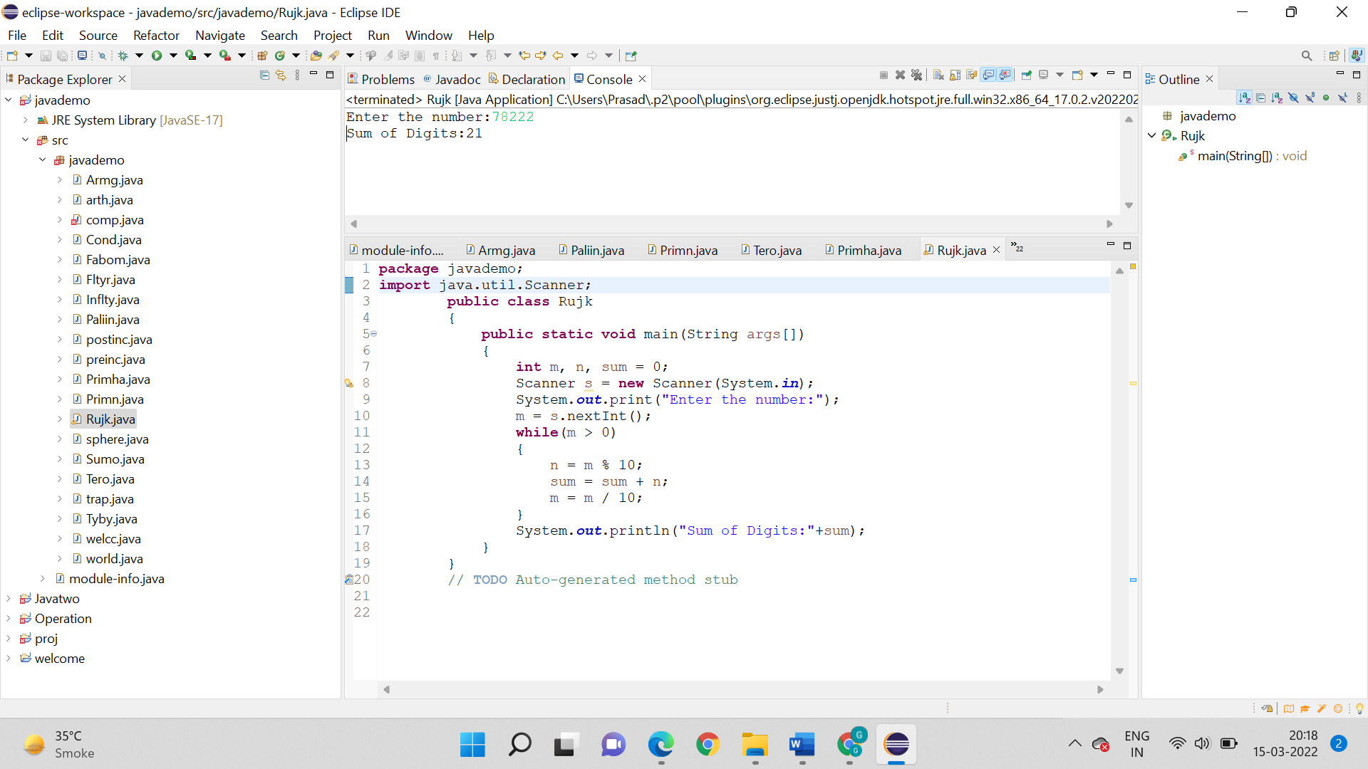

**Output:**



**5. Write a program to determine whether the number is Armstrong or not. (Display both the cases)**

**Not an Armstrong number:**

**Logic:**

* Start
* First package javademo is created along with main().
* Than int number is given value = 31.
* While loop is used remainder = originalNumber % 10;

result += Math.*pow*(remainder, 3);

originalNumber /= 10;

* Output is printed by the statement system.out.println
* Stop

**Code:**

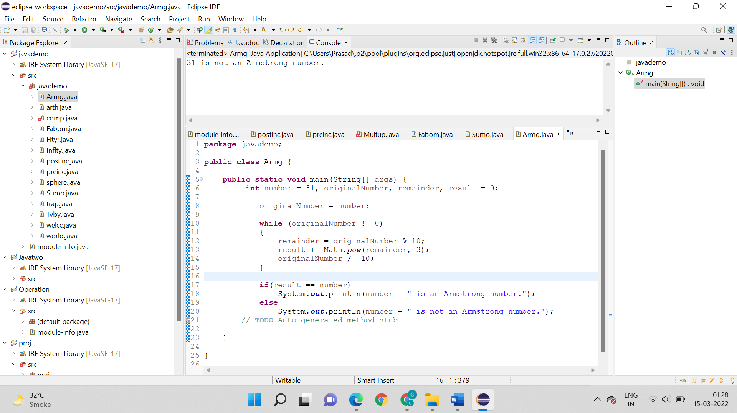

**Output:**

31 is not an Armstrong number.



**Armstrong number:**

**Logic:**

* Start
* First package javademo is created along with main().
* Than int number is given value = 31.
* While loop is used remainder = originalNumber % 10;

result += Math.*pow*(remainder, 3);

originalNumber /= 10;

* Output is printed by the statement system.out.println
* Stop

**Code:**

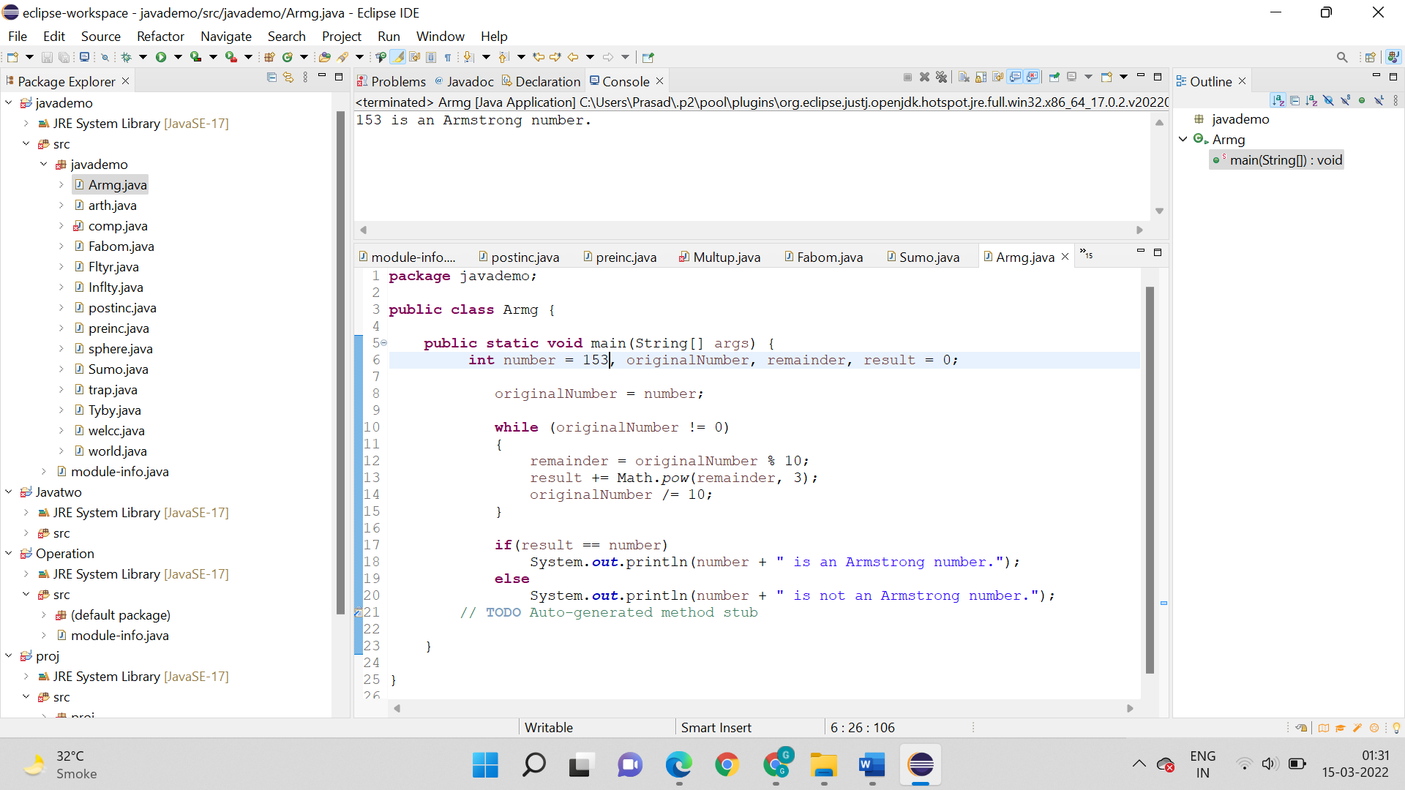

**Output:**

153 is an Armstrong number.



**6. Write a program to determine whether the number is Palindrome or not. (Display both the cases)**

**Palindrome number:**

**Logic:**

* public static void main(String args[]){
* int r,sum=0,temp;
* int n=23432;
* temp=n;
* while(n>0){
* r=n%10; //getting remainder.
* sum=(sum*10)+r;
* Stop

**Code:**

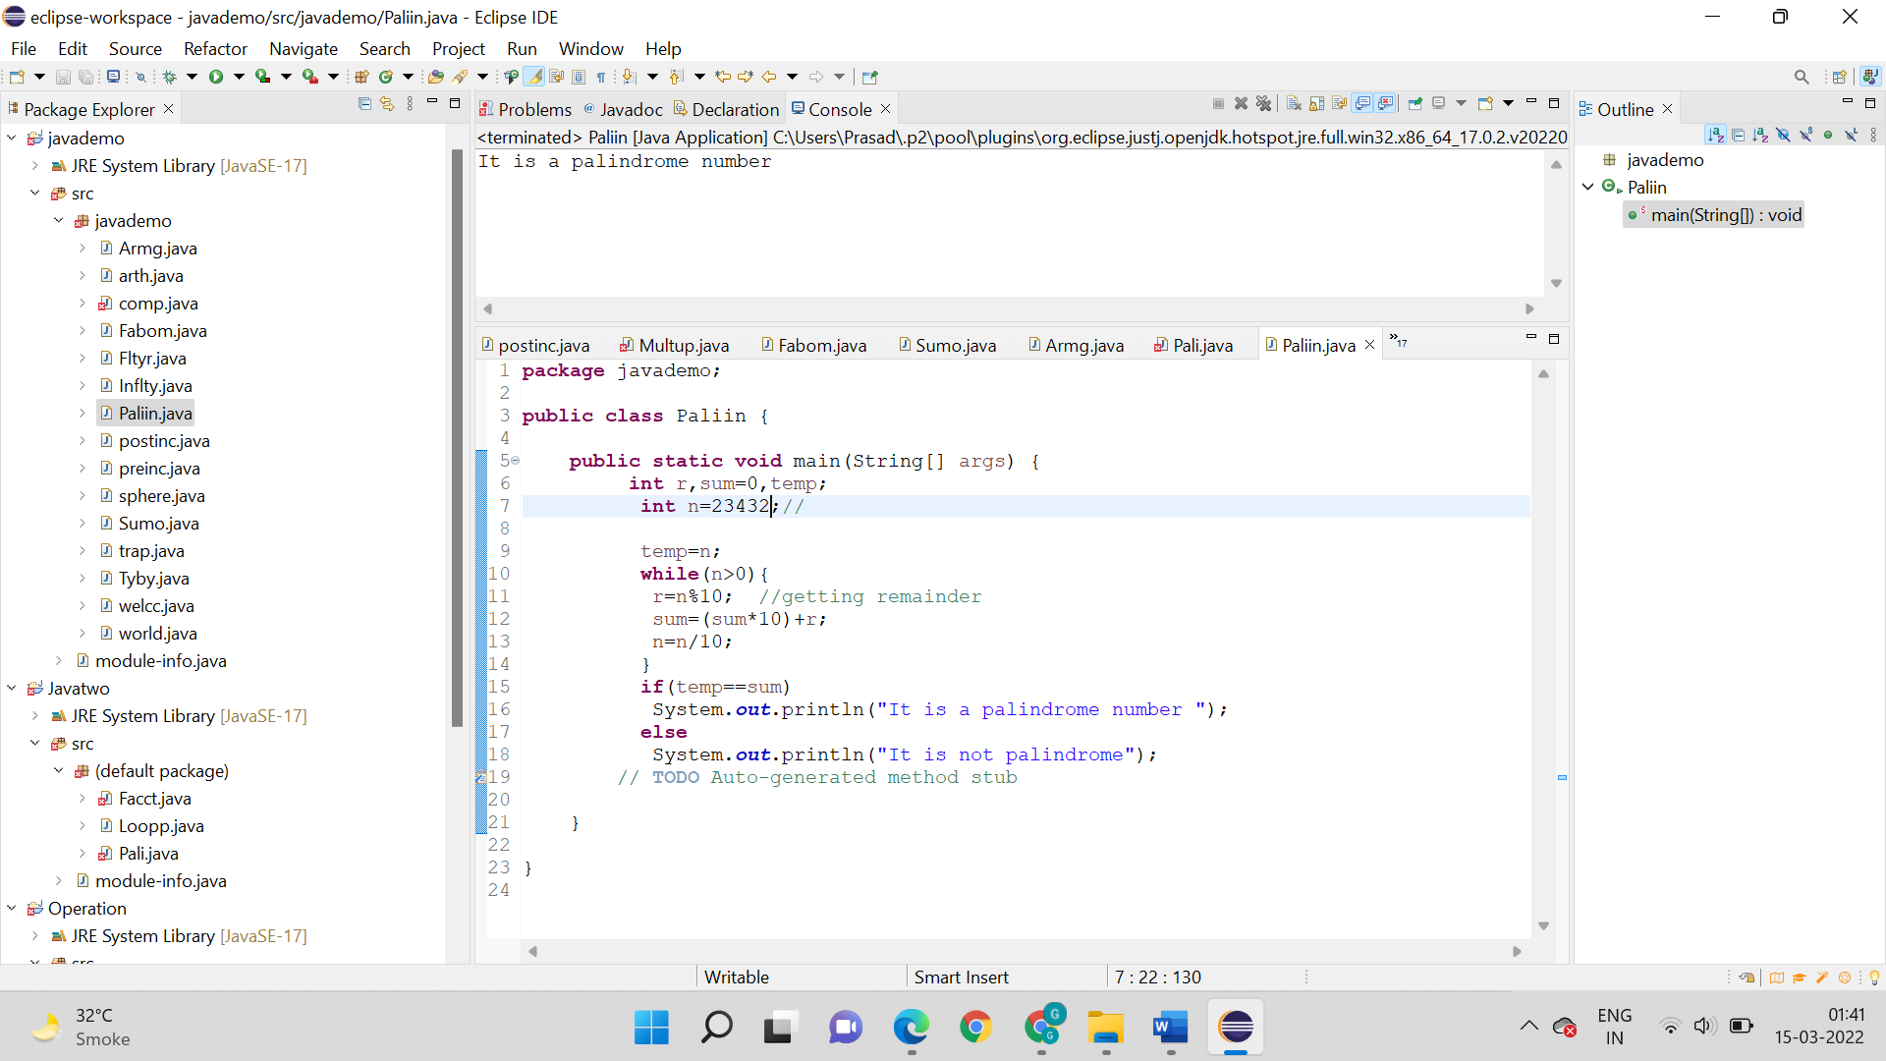

**Output:**

23432 is a palindrome number



**Not a Palindrome number:**

**Logic:**

* Start
* First package javademo is created along with main().
* Than values are assigned int r,sum=0,temp;
* int n=2438;//
* temp=n;
* Than loop is used while(n>0){
* r=n%10; //getting remainder
* Output is printed by the statement system.out.println
* Stop

**Code:**

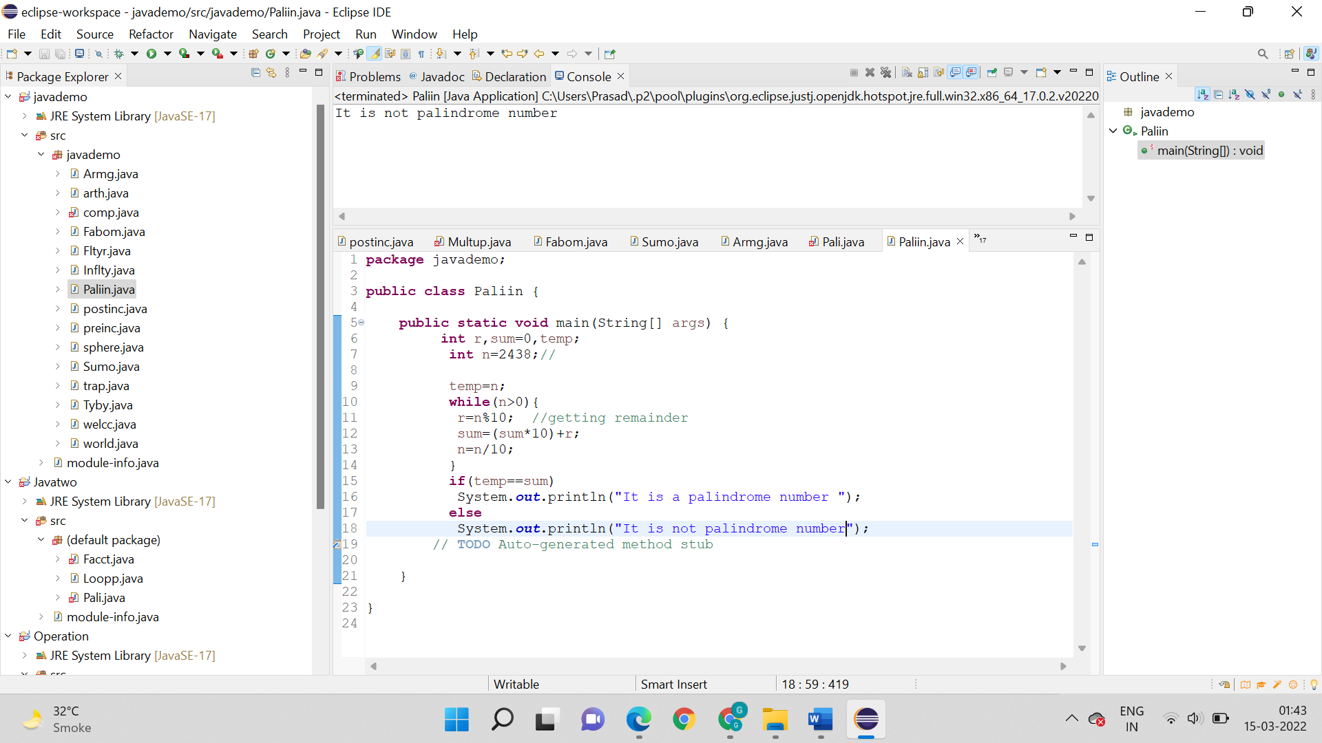

**Output:**

2438 is not a Palindrome number



**7. Write a program to**

**i. Determine whether the number is Prime Number or not. (Display both the cases). Use the break statement.**

**Prime Number:**

**Logic:**

* Start
* First package javademo is created along with main().
* Than int num is = 139
* For loop is used int i = 2; i <= num / 2; ++i
* Output is printed by the statement system.out.println
* Stop

**Code:**

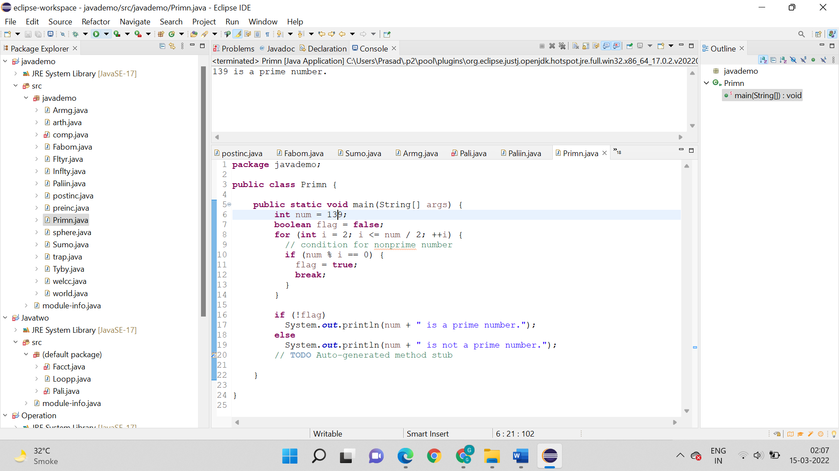

**Output:**

139 is a prime number.



**Not a prime number:**

**Logic:**

* Start
* First package javademo is created along with main().
* Than int num is = 119
* For loop is used int i = 2; i <= num / 2; ++i
* Output is printed by the statement system.out.println
* Stop

**Code:**

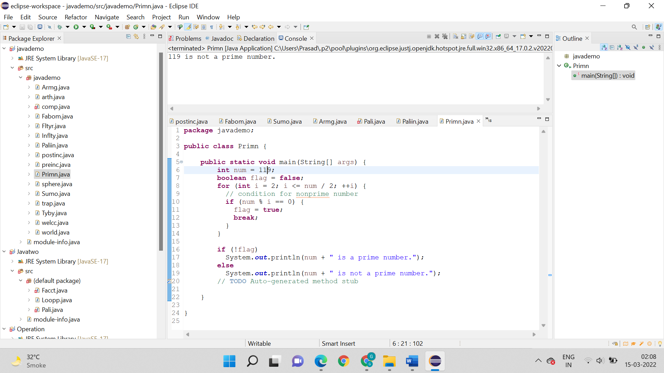

**Output:**

119 is not a prime number



**ii. Display the range of Prime numbers of a predefined number.**

**Logic:**

* Start
* First package javademo is created along with main().
* int i,m=0,flag=0;
* int n=3;//it is the number to be checked
* m=n/2;
* Break statement is used.
* Output is printed by the statement system.out.println
* Stop

**Code:**

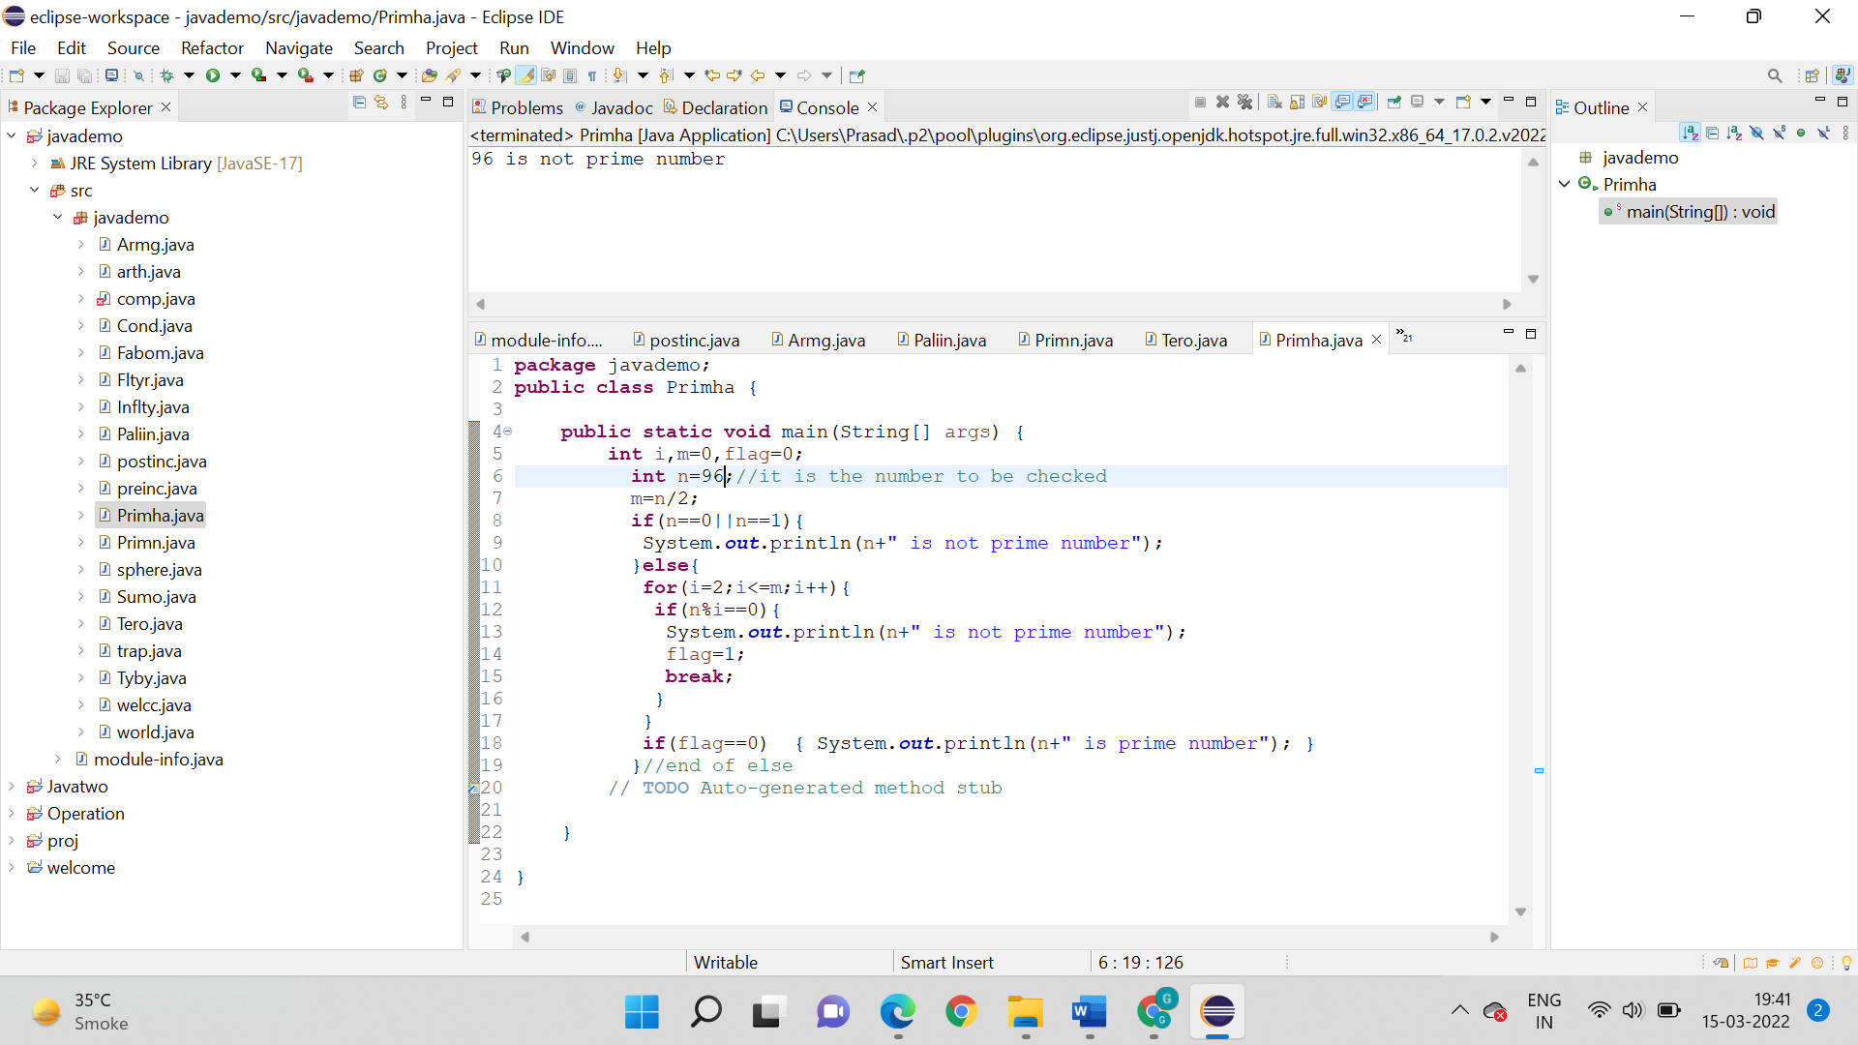

**Output:**



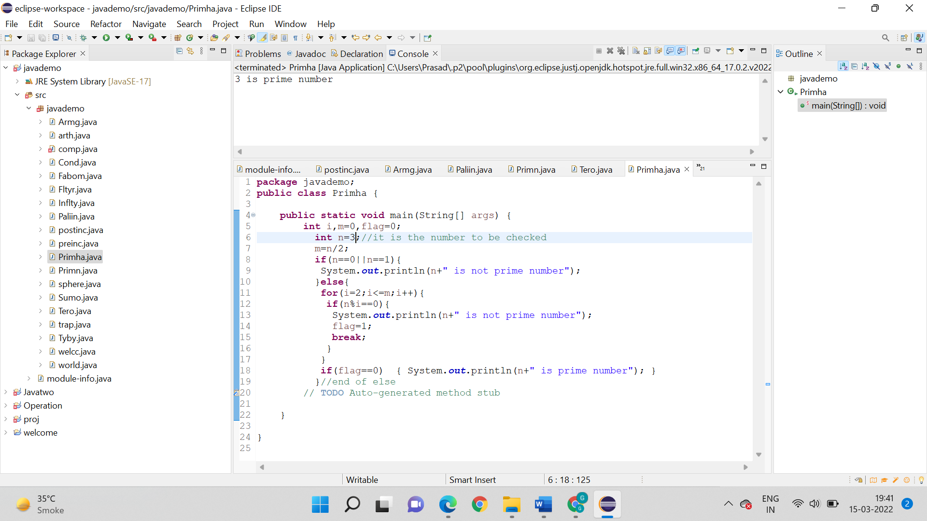

**8. Write a program to demonstrate the “ternary or conditional Operator”. Create a variable with a value and use all the relational operators with the conditional operator.**

**Conditional Operator**

**Logic:**

* Start
* First package javademo is created along with main().
* Than int num is = 139
* For loop is used int i = 2; i <= num / 2; ++i
* Output is printed by the statement system.out.println
* Stop

**Code:**

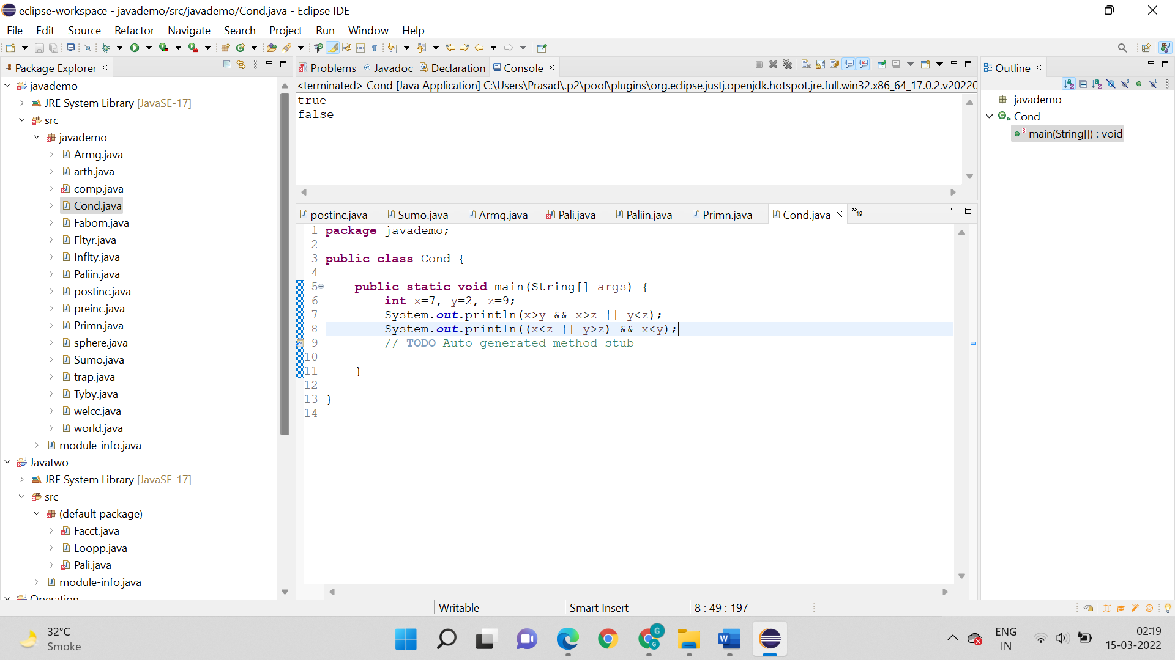

**Output:**



**Ternary Operator:**

**Logic:**

* Start
* First package javademo is created along with main().
* int x, y;
* x = 50;
* y = (x == 1) ? 71: 27;
* Output is printed by the statement system.out.println
* Stop

**Code:**

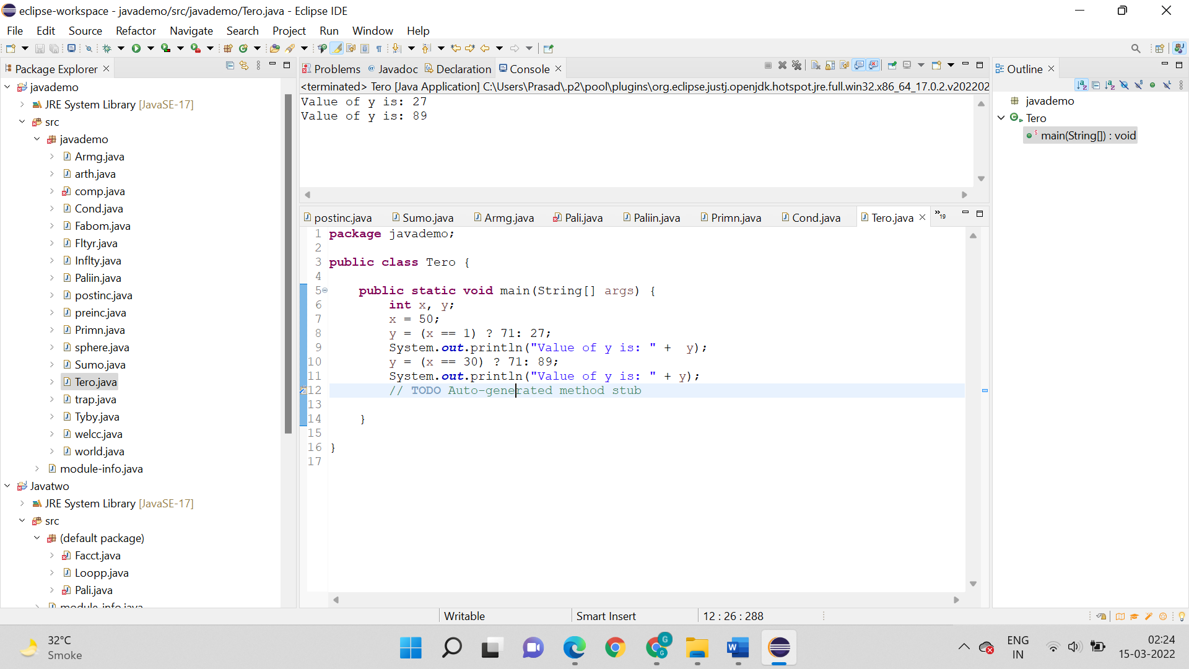

**Output:**

